**Breaking BEAR-riers Again:**

**The Solar Polar Bear**

Team 54 Project Technical Report for the 2024 IREC

Caleb M. Knight[[1]](http://applewebdata://FBA2C48B-27D1-4A43-8EE8-96002B6DD08D#_ftn1) and Erica N. Schulz[[2]](http://applewebdata://FBA2C48B-27D1-4A43-8EE8-96002B6DD08D#_ftn2)

*Lenoir-Rhyne University, Hickory, North Carolina, 28601, United States of America*

William L. Thorneburg[[3]](http://applewebdata://FBA2C48B-27D1-4A43-8EE8-96002B6DD08D" \l "_ftn3)

*Lenoir-Rhyne University, Hickory, North Carolina, 28601, United States of America*

Demmi L. Ramos[[4]](http://applewebdata://FBA2C48B-27D1-4A43-8EE8-96002B6DD08D#_ftn4)

*Lenoir-Rhyne University, Hickory, North Carolina, 28601, United States of America*

Christina E. Fisher[[5]](http://applewebdata://FBA2C48B-27D1-4A43-8EE8-96002B6DD08D#_ftn4)

*Lenoir-Rhyne University, Hickory, North Carolina, 28601, United States of America*

Michael Gerbitz [[6]](http://applewebdata://FBA2C48B-27D1-4A43-8EE8-96002B6DD08D#_ftn4)

*Lenoir-Rhyne University, Hickory, North Carolina, 28601, United States of America*

Ashley Castillo Mangandid[[7]](http://applewebdata://FBA2C48B-27D1-4A43-8EE8-96002B6DD08D" \l "_ftn3)

*Lenoir-Rhyne University, Hickory, North Carolina, 28601, United States of America*

Keifer Cuppett[[8]](http://applewebdata://FBA2C48B-27D1-4A43-8EE8-96002B6DD08D#_ftn4)

*Lenoir-Rhyne University, Hickory, North Carolina, 28601, United States of America*

Kaleigh Sloop[9]

*Lenoir-Rhyne University, Hickory, North Carolina, 28601, United States of America*

Nathaniel Orlowski[[10]](http://applewebdata://FBA2C48B-27D1-4A43-8EE8-96002B6DD08D#_ftn4)

*Lenoir-Rhyne University, Hickory, North Carolina, 28601, United States of America*

Red text is just my annotations after the competition for memory of how it all went

[[1]](http://applewebdata://FBA2C48B-27D1-4A43-8EE8-96002B6DD08D#_ftnref1) Team Lead, Engineering Physics, 154 South Harbor Watch Drive, Statesville NC, 28677

[[2]](http://applewebdata://FBA2C48B-27D1-4A43-8EE8-96002B6DD08D#_ftnref2) Documentation Lead, Chemistry, 831 Manor Shores Rd, Henderson NV 89002

[[3]](http://applewebdata://FBA2C48B-27D1-4A43-8EE8-96002B6DD08D#_ftnref3) CAD specialist, Engineering Physics, 625 7th Ave NE, Hickory, NC 28601

[[4]](http://applewebdata://FBA2C48B-27D1-4A43-8EE8-96002B6DD08D#_ftnref4) Payload Lead, Mathematics, 822 7th Ave Pl SW, Hickory, NC 28602

[[5]](http://applewebdata://FBA2C48B-27D1-4A43-8EE8-96002B6DD08D#_ftnref2) Payload Lead, Biochemistry, 111 Powe St, Morganton, NC 28655

[[6]](http://applewebdata://FBA2C48B-27D1-4A43-8EE8-96002B6DD08D#_ftnref3) Rocket Specialist, Computer Science, 51 Hit and Miss Road, Taylorsville NC 28681

[[7]](http://applewebdata://FBA2C48B-27D1-4A43-8EE8-96002B6DD08D#_ftnref4) Payload Specialist, Department Name, 761 8th Ave CT SE, Hickory, NC, 28602

[[8]](http://applewebdata://FBA2C48B-27D1-4A43-8EE8-96002B6DD08D#_ftnref2) Business Specialist, Business, 2053 Wellington Ave, Newton, NC 28658

[[9]](http://applewebdata://FBA2C48B-27D1-4A43-8EE8-96002B6DD08D#_ftnref4) Social Media Lead and Payload Specialist Department Name, 5385 Pittstown Rd, Hickory, NC 28602

[[10]](http://applewebdata://FBA2C48B-27D1-4A43-8EE8-96002B6DD08D#_ftnref3) Avionics Lead, Dual Enrollment Engineering Physics, 4730 16th St. Pl. NE, Hickory NC 28601

**The Lenoir-Rhyne University B.E.A.R. (Ballooning, Engineering, and Rocketry) Team is entering a four-inch diameter and approximately 8 and ½ foot long rocket to compete in the** **10,000 ft above ground level apogee, commercial off-the-shelf solid propulsion system category. The rocket will attempt to reach a 10,000-foot apogee flying a Cesaroni L1115 motor. The four-kilogram payload section has three goals. The primary objective is to test the functionality of thermoelectric coolers. Two cameras will be placed in the cooled compartment to capture footage of the launch. Additionally, an egg restraint system will be implemented to provide** **a safe flight for a medium-sized egg. The team aims for a safe recovery using standard dual deployment strategies. If successful, a drogue parachute will be deployed at apogee and a 5-foot main parachute at 800 feet above ground level, with the entire rocket descending in a “laundry line” style to land gently while all pieces main tethered. As a product of multiple test launches and other ground level testing, as well as computer evaluation done in OpenRocket, the team has faith in the success of this project.**

1. **Nomenclature**

AGL = above ground level

BRB = BigRedBee

C = Celsius

Cd = Coefficient of drag

COTS = commercial off-the-shelf

F = Fahrenheit

ft, ‘ = feet

ft/s = Feet per second

FW = Featherweight

FOR = Flyer of Record

g = grams

GPS = Global Positioning System

in, “ = inch(es)

IREC = Intercollegiate Rocket Engineering Competition

k = thousand

lb = pound

mm = millimeters

m = meters

NiMH= Nickle Metal Hydride

PETG = polyethylene terephthalate glycol

PF = Perfect Flight Stratologger

RSO = Range Safety Officer

SAC = Spaceport America Cup

TRA = Tripoli Rocketry Association

**II. Introduction**

The Lenoir-Rhyne University B.E.A.R. Team is competing in the 2024 IREC Spaceport America Cup in the 10k COTS category. The name B.E.A.R. stands for Balloons Engineering and Rocketry and aims to provide description that encompasses the actions and interests of the club within these fields. This club is open to all students of Lenoir- Rhyne University but is typically composed of students whose majors align with the technical aspect of the group and yet for the second year in a row the team is predominantly comprised of non-engineering physics students. The team has newly achieved the status of an academic team on Lenoir-Rhyne University’s campus, allowing funding to be provided by the School of Natural Science and Mathematics. Additional funding is also graciously provided by Todd and Kelly Burwell, the Aerojet Rocketdyne Foundation, North Carolina Space Grant, and several other generous donors, with a supplemental portion coming from team led fundraising endeavors. The team is lucky to have Dr. Douglas Knight as the team faculty sponsor and TRA L2 certified rocket advisor to provide guidance and assistance while meeting academic and competition requirements. Under the guidance of Dr. Knight, the team has been able to explore new projects relevant to their majors while also developing new skills as the demand arose. The diversity in majors represented within the team allowed for unique learning experiences for all and the opportunity for members to step out of their comfort zones. In addition to the preparations for the 2024 SAC, the team had the opportunity travel to Arkansas during the recent total solar eclipse and launch a balloon containing student research projects and a constellation of payloads received from local community college ballooning teams. The team took this opportunity, all made possible by the North Carolina Space Grant, to practice tracking methods and electronics for the 2024 SAC and were able to achieve complete recovery. Each member of the team has, at minimum, made progress towards receiving a TRA L1 certification, with one member going beyond and preparing for his TRA L2 certification flight later this year. In addition to building technical expertise and refining build strategies through personal certifications, the team has gained valuable experience during each of the two test flights completed with the full-scale competition rocket. Having completed the test flights, additional ground testing, and performed simulations using OpenRocket, the team is confident that The Solar Polar Bear is safe to fly and ready to attempt a 10k ft apogee flight.

1. **System Architecture Review**
2. **Integrated System Overview**

The Solar Polar Bear has been designed to stay within the boundaries of amateur rocketry, the rules of the Spaceport America Cup, and be able to fly under an L2 certification. To achieve the goal of a 10,000 ft apogee, the team had to ensure the rocket was light enough while also maintaining the structural strength needed to withstand the thrust forces provided by an L1115 motor. Fiberglass tubing, centering rings, couplers, and bulkheads from Wildman Rocketry and Mach1 Rocketry comprise the main structural components that withstand the loads of the flight profile. The motor mount tube is 75 mm phenolic with four centering rings for attachment to the rocket outer shell. Centering rings are epoxied to the motor mount and epoxied to the fin can tube using West Systems 405 epoxy. All joints or connections on the rocket body, internal or external, that may undergo any significant loading utilize this epoxy.

The rocket airframe is constructed of four-inch fiberglass tubing from Wildman. The altimeter bay consists of a Wildman fiberglass coupler and 3/16” fiberglass bulkheads. The motor mount tube is 75 mm phenolic, held in place by 1/8" fiberglass centering rings. The recovery system for the rocket includes a two-foot Rocketman High Performance Drogue at apogee followed by a bright orange Rocketman High Performance 60” Parachute at 800 feet, both deployed by black powder charges. The drogue will be within the fin can, deployed by a charge plate, and the main parachute will be packed within the main parachute bay above the altimeter bay. The rocket itself will be 104 inches long and weigh about 33.2 pounds on the pad. The stability margin will be 1.89 ensuring stable flight during the boost and coast phases. Inside the payload tube there is an 8.8-pound scientific payload that integrates the rocket nosecone so that it is affixed to the top of the payload tube.

1. **Propulsion Subsystems**

The Solar Polar Bear will utilize a Cesaroni Technologies 5015L1115-P to attempt to carry the launch vehicle and payload to the desired 10,000 ft AGL apogee. The Cesaroni Technologies 5015L1115-P, commonly referred to as the L1115, is a 75 mm 4 grain propellant that uses the Cesaroni Pro75 4 grain casing and 75 mm closures. This motor has 5015 Newton Seconds of Impulse, a maximum thrust force of 1713 Newtons, an average thrust of 1119 Newtons and burns for approximately 4.5 seconds. This data is from Thrustcurve.org but due to acceptable motor variations in performance the actual performance of the rocket motor may vary. Acceptable variation in actual motor performance from tested must be less than 6.7% of the standard deviation for total impulse and the average thrust must not vary more than 20% of the reported average thrust. Using this motor, the predicted rail exit velocity is 103 ft/sec, which is acceptable for safe launch.

1. **Areo-Structures Subsystems**
2. *Nose Cone*

The nosecone was printed using PETG filament using a QIDI Tech 1-mates 3D printer. The nosecone curvature was optimized with OpenRocket to maximize apogee of the rocket. The wall thickness of the nosecone is ¼ inch. The nosecone was sanded and painted to produce a smooth finish. A metal tip for the nosecone is not utilized due to the temperature properties of PETG and the short time the rocket is in the transonic regime (velocity greater than Mach 0.8). The nosecone is affixed to the payload using a center ¼x20 threaded rod epoxied to the top of the nosecone and attached to the top payload bulkhead using a nylon insert 1/4x20 nut. The nosecone will also be affixed to the body tube via the nosecone shoulders using four 4-40 nylon reusable rivets, commonly used in high power rocketry

Figure 1 Altimeter Sled Layout

1. *Payload and Main Body Tubes*

The payload bay tube is a 4-inch diameter, 27-inch-long fiberglass coupler tube from Wildman Rocketry. Stepped bulkheads will be utilized to cap the ends of the payload tube with four holes for the threaded rods to extend past the ends of the bulkhead approximately ¾ of an inch with ¼x20 nylon insert nuts used to keep the system all together.

A fiberglass coupler is epoxied to the aft end of this payload bay tube with a fiberglass bulkhead with 5/16” U-Bolt epoxied inside the coupler. This section is inserted into the main parachute bay upon assembly. There will be small holes in this tube as appropriate to switch on different parts of the payload and should not interfere with structural integrity of this section of the rocket. Holes for two cameras will also be cut into the payload tube with a 90-degree fold mirror affixed to one of the holes so one of cameras will look out to the horizon and the other camera will look back down the rocket.

1. *Altimeter Bay*

The altimeter bay’s main structural components are two 1/8th inch thick fiberglass sheets held together by three 4/40 screws and three 4/40 bolts. These three bolts and screws have Loctite applied to them before launch to mitigate the risk of them coming loose in flight due to vibrations. The altimeter bay tube itself is 12 inches long, with the vent band being 4 inches long. There are four half-inch holes in the middle of the altimeter bay vent band to turn on each of the four electronics. These two fiberglass sheets are 11 inches long, and 3.75 inches wide. The through rods are threaded through four (two on each side) three-inch-long carbon fiber tubes which are our through rod holders. These tubes are epoxied to the underside of the electronic side of the altimeter sled. On the front of the altimeter bay, all the electronics are present. The electronics present are the RRC3, Perfect Flight StratoLoggerCF, Big Red Bee 70 cm 100 MW, and the Featherweight GPS tracker. Each electronic has its own wiring holes for their wires to pass through. The BRB (Big Red Bee) and FW (Featherweight GPS tracker) are wired in series with the rotary switch and their respective batteries enabling them to be turned on via the rotary switch. The RRC3 and the Perfect Flight StratoLoggerCF (PF) are wired directly to the switch, and directly to the battery. The PF and RRC3 each have a drogue and main wires that go to each end of the altimeter bay. The RRC3 will provide the primary for the main charge and the drogue charge. The StratoLoggerCF will provide the backup for the main charge, as well as the backup for the drogue charge. All electronics are bolted to the top fiberglass sheet using 4/40 screws and bolts. These screws and bolts are strengthened by Loctite that is applied before launch. This is to mitigate the risk of the bolts coming loose due to A person in a blue hat and gloves working on a model of a rocket
vibrations of the rocket. The terminal blocks that transfer power from the batteries to the electronics, as well as the battery holders are epoxied to the bottom fiberglass sheet. There are two, four pack NIMH 1.4V batteries for the trackers, and two, 9V batteries for the altimeters. They are sanded before being epoxied to mitigate the risk of them shearing off due to launch G forces. The batteries themselves are friction fit, as well as zip tied to battery holder to mitigate the risk of the batteries falling out or being dislodged due to launch G forces. The rotary switches fit through both fiberglass sheets and are screwed tight using the provided bolt given by the manufacturer. This bolt as well as the threads of the rotary switch, Loctite is applied to mitigate the bolts coming loose due to vibrations during launch. The wires for the primary and backup charges are threaded through the space in-between the two fiberglass sheets to their respective sides and are attached to their respective terminal blocks. For the forward-facing bulkheads, the terminal blocks have their respective e-match that is wired into them that is inside of the Hard Tough Resin printed charge wells. For the aft facing bulkheads, the primary and backup wires are wired into the terminal blocks, which then are connected to two male JST connectors, these of which connect to the charge plate in the fin can. The altimeter sled is then attached together by threading the quarter twenty rods through the through rod holders and then attaching one bulkhead with four quarter twenty bolts total (one for each through rod). This process is repeated for the other side, then all the bolts are tightened. The altimeter bay is then attached via quicklink to the U-bolts on either side of the rocket. The side attached to the fin can shock cord is attached first, while the side attached to the main parachute bay is attached second. This is due to the charge plate at being inserted and the JSTs being connected prior to connecting the quick 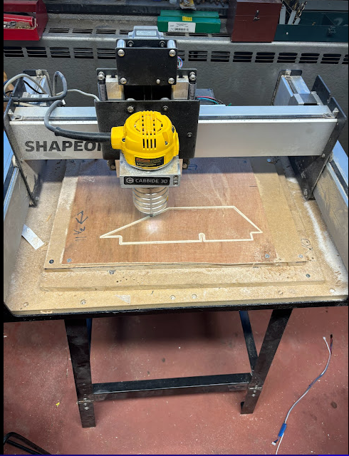links to the fin can shock cord.

Figure 2 Fin Can Construction

Figure 3 Fins being cut on Shapeoko router

We used an Altus EasyMini instead of the perfect flight stratologger in flight due to technical difficulties with the PF

1. *Fin Can*

The fin can is 43” long with pre-cut fin slots from Wildman. 1/8” centering rings are used to center the 75mm LOC/Precision Phenolic motor tube to minimize weight and allow structural support. There are four centering rings to hold the tube in place, two of which interlock with the fins. These were attached to the motor mount tube and the fin can tube using West Systems 105 Epoxy system with fast cure. Fin attachment to the fin can body tube is described in the next section. The negative retention system is an Aero Pack RA75mm that is screwed and epoxied into the rear centering ring as well as epoxied to the fin can.

1. *Fins*

The fins are constructed using 3/16” thick G10 fiberglass sheets cut to size using a Shapeoko Router with a 1/4“fiberglass router bit. The dimensions of the fins are as follows: overall length of 12”, semi-span length of 3”, root cord length of `12”, tip cord length of 5”, leading edge length of 6.8”, and a trailing edge length of 3.48”. The leading and trailing edges of the fins have been beveled using a sander. The fins have a middle slot cut into them on the root cord to interlock with the centering rings on the motor mount tube to allow a secure and sturdy fit to the vehicle. The fins are primed with Rustoleum primer and then sanded smoothly. An approximate two-inch-wide strip of fiberglass was cut and laid within the area of the fillet and used as an epoxy-based reinforcement of the fin fillet. Body filler, epoxy and hand sanding were used to smooth out the roughness from this fin strengthening method. Fin flutter analysis used two different spreadsheets found online and each agreed well. The shear modulus A plastic wrap on a piece of plastic
of G10 fiberglass was seen to vary between 600,000 and 892,000 psi depending on the reference source and both analysis methods showed a fin flutter velocity approximately three times greater than the maximum velocity of this rocket. One of the fin flutter analysis spreadsheets is from a Peak of Flight Newsletter #615 from an article authored by John Bennett. The other spreadsheet is from a Rocketryforum.org forum post.

Figure 4 Fiberglass Cloth added to Fin Can

1. *Charge plate*

The charge plate is a 4 inch long by 3.9 inches in diameter coupler piece that is threaded through the aft shock cord with the aft end attached to the eye bolt above the motor, and the forward end attached to the aft bulkhead of the altimeter bay. The charge plate itself is responsible for deploying the drogue chute. There is one primary charge, and one secondary charge from their respective primary altimeter with the primary altimeter being the RRC3, and the PF being the secondary altimeter. The screw terminal blocks have one side that is for each e-match, and the other side has the two female JST connectors, each of which are 24 inches long. They are each this long to connect to the male JSTs on the aft facing bulkhead. When the charges are ignited at apogee for the fin cans separation the JST will pull apart leaving the fin can separated.

1. **Recovery Subsystems**
2. *Flight Computer System*

The RRC3 is the primary altimeter for the main and drogue charges. The main parachute charge is ignited at 800 ft AGL. The primary drogue charge is ignited at apogee. The PF is the secondary altimeter for the main and drogue charges. The secondary main parachute charge is ignited as a backup at 700 ft AGL. The secondary drogue charge is ignited at apogee plus one. Lifetime testing of both altimeters demonstrated that while in wait mode for launch, both altimeters continued to sense for launch for greater than 8 hours. The test was terminated after this length of time due to the sufficiency of the test.

Replaced PF with altus easymini

1. *Wiring diagrams (Altimeter Bay)*

For the altimeter bay, there are two, four pack NIMH 1.4V batteries that power the two trackers. They are wired in series with the rotary switches so they can be turned on with the rotary switches. There are two 9V batteries that power the two altimeters. The rotary switches are directly attached to the key switch terminals on the altimeters. The two 9V batteries are then attached to the altimeter's terminals directly. All terminal blocks are screw terminal blocks, and the wires terminate into them. Screw terminal blocks are used to mitigate the risk of the wires coming loose during the vibrations and G forces of launch. The black wires on the underside of the altimeter bay represent ground, and the red wires represent voltage. This is the color code that is coming from the battery. The color code for the altimeter's blue wires. These blue wires represent switches and both the positive and negative wires for each respective altimeter. The yellow wire pair are used to denote the FW wires. The yellow and black wire pair are used to denote the BRB wires. A pair of blue wires are used to denote the PF wires and a pair of blue wires are used to denote the RRC3 wires. The wires for each electronic are put through their respective wire holes, this enables the wires to be neater than without specified holes. Each altimeter provides a charge to each end of the altimeter bay. The PF charge wires are red both primary and backup, while the RRC3 charge wires are black both primary and backup. The RRC3 is the primary altimeter for the main and drogue charges. The primary charge is ignited at 800 ft. The primary drogue charge is ignited at apogee. The PF is the secondary altimeter for the main and drogue charges. The backup primary charge is ignited as a backup at 700 feet AGL. The backup drogue charge is ignited at apogee plus one.

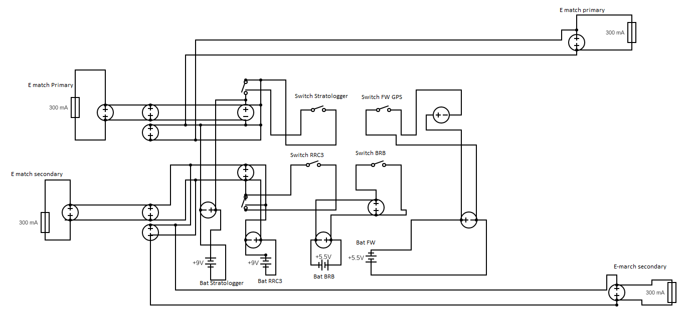

Figure 5 Altimeter Bay Wiring Diagram

1. *Tracking*

The Featherweight GPS is responsible for tracking the rocket via GPS. There is a Featherweight ground station that communicates to the tracker. The ground station communicates via Bluetooth to a smartphone. There is an app called IFIb that gives latitude and longitude of the rocket in real time as well as altitude. This app allows the tracker and ground station to connect and communicate information to a smartphone.

BigRedBee 70 cm Radio Beacon radiating up to 100 mW of signal. The BRB or (BigRedBee 70 cm Radio Beacon) communicates on the frequency of 433.950 on the call sign of KM4JIE. The BRB will send a communication packet to the radio receiver, which is a YAESU FT1D radio receiver once every second. The YAESU FT1D radio receiver is attached to a Yagi antenna which allows for a greater range of radio communication. This allows for the operator of the radio receiver to track the rocket efficiently. This is because as the communication packets are sent out, it displays on the radio receiver the signal strength of the communication packet being sent. With a signal strength of 1, the rocket is either far away, blocked by foliage or in another direction. With a signal strength of 5, the rocket is closer than it was at one, and the user of the radio receiver would follow the increasing signal strength as it would increase to its maximum strength of nine. Then the user would use the Yagi antenna to pinpoint which direction the rocket is in and then use eyesight to locate the rocket

For recovery of the rocket, a drogue and main parachute system are utilized. The drogue parachute system involves a yellow 24-inch Rocketman parachute attached to a 25’, 5/8” diameter nylon shock cord from Loc Precision with sewn loops on each end. An orange 6x6 Dinochutes parachute protector will be used to protect the parachute from the hot ejection charge gases. 1540 lb stainless steel quicklink from McMaster-Carr will attach each end of this shock cord to the altimeter bay and motor forward eyebolt. The main parachute system will be deployed in laundry line fashion with the shock cord between the altimeter bay and payload bay with no parachute attached and another shock cord attached to the payload bay with the main parachute attached to the end of this shock cord. The main parachute is a 60-inch Iris high performance parachute from Rocketman with a Cd of 2.2 that slows the rocket down to less than 28 ft/sec when touchdown occurs.

1. *Drogue Parachute*

The drogue parachute is a 24” diameter bright yellow Rocketman Pro Experimental Drogue made of 1.9oz ripstop nylon, ⅜” polyester lines, and a Cd of .97. The drogue is sized to bring the vehicle in from apogee to 800’ safely. This will be slow enough not to cause tangling but fast enough that it will not drift far from the launch site. This parachute is bright neon yellow in color. The parachute protector is an orange 6x6 Dinochutes parachute protector.

1. *Main Parachute*

The main parachute is an orange and gray Rocketman High Performance 60” Iris Parachute. According to the vendor’s specifications, this parachute has a Cd of 2.2. The parachute is very lightweight, allowing the team to minimize the rocket's weight. This is an annular style parachute with 16 shroud lines that are 250 lb. test. At the attachment point to the shock cord is a 1500 lb. barrel swivel. The parachute system as designed should bring the vehicle safely. The parachute protector is an 18”x18” Rocketman Kevlar parachute protector

Figure 6 Laundry Line recovery decent

**Photo by Wes Munn**

1. *Recovery Attachments*

Please note that all recovery attachment devices have been flown on test flights with no issues seen**.**

Quicklinks: Stainless Steel from Lowe’s with a 1540-pound working load are used for attaching the shock cords to the altimeter bay bulkheads, the forged eyebolt attached to the front-end closure of the motor and the aft bulkhead of the payload bay.

Shock Cord: 5/8” diameter, tubular nylon shock cord rated at 2200 pounds of tensile strength from Loc Precision. This shock cord has pre-sewn loops on each end and can safely stretch to 20% of the original length without breaking. Shock cords are deployed in a laundry line configuration for the main parachute for ease of recovery and less jolt on the payload when it hits the ground. In this configuration, there are two 25’ cords and one 12’ cord, with the shorter cord being the primary attachment to the main parachute.

Swivels: 1500-pound barrel swivels by Rosco tackle are used for attaching the main parachute to the accompanying shock cord.

U-bolts: 304 Stainless Steel U-Bolt, 5/16"-18 Thread Size, 1-1/8" inner diameter are used on the ends of each body section. In addition, U-bolts are secured with epoxy prior to construction of body sections.

1. **Payload Subsystems**

Our payload was inspired by CubeSat structures and therefore utilizes a stacking system. There are ten 2.5-inch-tall compartments stacked on top of one another, separated by 3.625-inch diameter fiberglass platforms of 1/8-inches thick. Four ¼-inch through rods will run through the edges of the platforms to connect them together held by nuts. This structure will be placed in a 3.75-inch fiberglass tube 27-inches long, with an inset coupler on the aft side and a flushed external coupler on the forward side. The fiberglass tube then slides into the rocket and is retained through using plastic rivets.

The team has had previous issues with the avionics bay overheating on the launch pad. Therefore, our primary payload project will be testing the functionality of a thermoelectric cooler to allow for more cooling and airflow within the payload. The team is doing this in hopes of implementing this system into our main avionics bay in the future. The thermoelectric coolers will be separated by a compartment and will frost on one side to keep that compartment cool and expel heat out of the other side. Attached to the thermoelectric coolers will be heat sinks and fans to push the heat further away from the cooled compartment and outside of the rocket through the placed vent holes. The goal is to mitigate temperature increase from sitting on the launch pad.

Inside the cooled compartment will be two temperature sensors and two Rum Cam 6 cameras: one looking straight out towards the horizon and one pointing downwards using an external fold mirror. Last year, our camera positioning was not optimal, and we encountered some challenges that prevented the team from obtaining the desired footage. Also, the Rum Cam 2 cameras have begun to overheat and shut off while recording. These challenges have led the team to take a different, more purposeful approach with camera placements and camera cooling.

The payload will contain an Arduino connected to the two temperature sensors inside the cooled compartment and each temperature sensor in the heated compartments. The Arduino will be connected to AA Nickel–metal hydride batteries, the cameras, and fans to AAA Nickel–metal hydride batteries, and the thermoelectric coolers to 6V Lantern batteries. As an additional experiment, the team is implementing an egg restraint system to see if a fragile object can withstand the launch and landing forces – measuring force changes throughout the launch from liftoff to apogee to landing. The restraint was built using foam and cushions to soften the forces but is placed tightly in its compartment so there is no leeway for movement.

The order of the payload components from forward to aft per compartment is (1) egg restraint system, (2) thermoelectric cooler, heat sink, fan, temperature sensor, and AAA batteries (3) two cameras and two temperature sensors, (4) another thermoelectric cooler, heat sink, fan, temperature sensor, and four SPST switches for the fans and coolers, (5 and 6) an Arduino, one AA battery pack, and three AAA battery packs, (7 and 8), a 6V Lantern battery, and (9 and 10) the other 6V Lantern battery. The payload will remain within an extended nose cone base tube and come down with the rest of the rocket in a laundry-line format for an easy recovery.

1. **Mission Concept of Operations Overview**
2. **Assembly**

This assembly assumes the altimeter bay has been fully tested and is in ready-to-fly configuration. First, insert Cesaroni L1115 motor into fin can and be sure to tighten Aeropack motor retainer to prevent rear ejection of the motor during flight. Next, attach quicklink attached to fin can shock cord to eyebolt extending from the front of the motor casing. Put the other end of the 25 ft shock cord through the middle of the charge plate and insert the charge plate into the fin can until flush with eyebolt at the forward end of the motor. Make sure wires of the charge plate are hanging out of the end of the fin can. Next, attach quicklink attached to other end of the fin can shock cod to the aft bulkhead of the altimeter bay and then attach drogue parachute protector to fin can shock cord approximately one foot from the drogue parachute attachment points if not already attached. Now the drogue parachute is attached to fin can shock cord and reef the fin can shock cord using small thin rubber bands typically used for hair. Next, fold the parachute and wrap it inside the parachute protector using the “burrito” method and then carefully insert the fin can shock cord and aft parachute wrapped inside the parachute protector into the front open portion of the fin can. Be sure to keep the wires from the charge plate from getting tangled into the shock cord and are still exiting the front of the fin can. Attach the charge plate wires to the drogue deployment wires from the aft end of altimeter bulkhead and carefully insert the aft end of the altimeter bay into the front portion of the fin can making sure to keep all wiring and shock cords inside the fin can and not bound between the between the coupler portion of the altimeter bay and the fin can. To insert the shear pins, carefully rotate the altimeter bay and align the marks so that the shear pin holes are coaxial. Once complete, insert #2 nylon shear pins into the shear pin holes and place and small piece of electrical tape over the heads of the pins to prevent accidental removal or ejection of the shear pins. The fin can section of the rocket is now assembled.

Figure 7 Launch Vehicle Fully assembled for charge testing

To assemble the forward section of the rocket, first attach the main parachute bay to the altimeter bay using 4 of the #4 nylon removable rivets. Be sure to check each rivet for a secure fit and change out rivets as necessary for a non-slipping fit. Next, attach the main parachute bay shock cord quicklink to the forward altimeter bay bulkhead and attach the other end of the main parachute bay shock cord quicklink to the payload bay bulkhead. Then connect the 12 ft main parachute shock cord (laundry line top cord) to the payload bay bulkhead using a quicklink If not attached, connect the main parachute protector to the main parachute shock cord about one foot below the main parachute bay attachment point and then connect the main parachute to the end of the main parachute shock cord. Be careful not to tangle the shock cord shroud lines when attaching the parachute to the shock cord swivel that is already attached to this shock cord. As with the other shock cord, reef the lines of the main parachute bay shock cord and main parachute shock cord using the rubber band hair ties previously used. Now, carefully fold the parachute and pack it within the parachute protector using the “burrito” technique and then insert both shock cords and protected main parachute into the main parachute bay. Next insert the payload bay section into the forward portion of the payload bay rotating to align with the shear pin holes. Insert shear pins per the technique mentioned in the preceding paragraph.

The payload should have already been assembled into the payload bay and securely attached to the nosecone and payload bay wall with a ¼x20 threaded rod epoxied to the center of the nosecone and to the nosecone reinforcement bulkhead. This rod will attach to the top bulkhead of the payload using a washer and nylon insert 1/4x20 nut. The payload bay with attached nosecone acts as a nosecone with long extended shoulders with a bulkhead inserted into the aft end of the nosecone shoulders. The nosecone will be attached to the payload body tube using four of the 4-40 reusable rivets.

1. **Preflight**

The team will carefully carry the fully assembled, flight ready rocket to RSO at designated preflight check-in area. The team business specialist will have possession of the binder containing copies of all documentation including all checklists. Once the final approval is given for launch from RSO, the team will carefully carry the rocket to the awaiting vehicle to be transported out to the single-stage pad. When carrying the rocket, the team will assure that 3 people at least will keep hands on it to assure safety before launch. When out at the pad, the FOR and team lead will listen to ESRA officials for instructions prior to relaying information to the entire team.

1. **Launch and Recovery**

The launch rail is lowered, and three people will help guide the rocket on the launch rail. This is to mitigate the risk of the rail guides breaking as the rocket is being loaded. After the rocket is loaded and the launch rail is carefully raised upright, a team member will verify that the launch angle is correct based on the launch conditions of that day. The team lead will then use a foot stool, or small step ladder to reach the open key switch holes in the vent band. The team lead will then use a flat head screwdriver to turn on the FW first, the BRB second, the RRCS third, and the PF fourth. After everything is verified to be nominal, and all electronics are working, the team lead will then step down from the ladder or stool. The FOR will install two Quickburst Super Fatboy igniters that are used to ignite the motor quickly and to reduce the risk of the motor chuffing. The team will then ride back to the viewing location and one of the team members will open the IFIb smartphone application for the FW to view its status and to check if it is operating nominally. The radio receiver for the BRB will be on and held by another team member and checked regularly to see if it is operating nominally. The team will then wait for the countdown of the rocket and watch the rocket launch while monitoring the FW and BRB trackers.

Once tracking leads the team to the rocket and attached payload (assuming we do not have a ballistic recovery), the team will initially, before any touching or moving of the rocket, take multiple pictures of the rocket and payload sections as seen on the ground. The team will then listen for the altitude of the rocket via beeps heard from each altimeter. Once this has concluded, our team lead Caleb Knight will turn off each altimeter to prevent any accidental deployment of possibly unspent charges. Using the appropriate quicklinks, the fin can will be separated from the altimeter bay and the payload section will be separated from the altimeter bay. The drogue parachute and shock cord will be stuffed inside the fin can and the other two shock cords and main parachute and stuffed inside the main parachute bay. Care is taken here not to damage either parachute or any other component of the flight vehicle. Each section is then carried by a rocket team member back to the vehicle and returned to base for post-flight check procedures by an ESRA official.

# **Conclusion and Lessons Learned**

## **Conclusion**

Throughout the year, despite facing such a drastic increase in participation, the team has constructed and successfully flown several iterations of the rocket it plans to fly at the 2024 SAC. Being a small university when compared to the other entrants has led to a smaller team than most but each member has worked extremely hard and made much needed contributions to ensure the quality of our rocket build. Based on the results from our two test flights and the corrective actions taken following any abnormal events, the team is confident it is safe to fly as close as possible to 10,000 feet AGL with the rocket and motor combination planned to compete in the 2024 SAC.

## **Lessons Learned**

1. *Communication and Teaching*

With a lot of new members on the team, we made sure communication was a top priority. As our team has over doubled in size this year, it has remained essential that strong communication is maintained. We did our best to include everyone, even if it meant we had to work at a slower pace. Including everyone also means ensuring open lines of communication, which for this team means a well-organized Discord server with separate channels for different tasks. With so many new members, teaching is crucial to the survival of the team beyond this year, and we want to ensure that if someone is missing for whatever reason, the launch is not dependent on the presence of that individual. For example, when working on the altimeter bay, the goal is that if the altimeter bay lead were not there, other members would be able to set everything up. We want all team members to understand the how and why behind the set up. We are beyond proud of how we have been able to work as a team.

1. *Measure Twice, Cut Once.*

Through the process of designing and building the Solar Polar Bear, there were several instances where double checking a measurement has saved us a lot of time and money and a couple of times where those checks were not made and were costly. It is very easy to get “launch fever” and just start completing tasks as fast as possible but that often comes at the cost of the quality we strive to achieve, forcing us to refabricate and replace components.

1. *Moving Forward*

As the team continues its life and members move on towards greater things, it is vital to the ongoing success of the team to make sure the information used stays in possession of the team. To ensure this moving forward, we have established a SharePoint page for all official SAC documentation, 3D models, .stl files, and launch notes. All of this is to be done on top of including new members in activities and teaching them vital skills at launches and in the team workroom to ensure that this team outlives its current members as they grow and move on to their next journey.

**Appendix A: System Weights, Measures and Performance Data**

|  |  |
| --- | --- |
| Basic Rocket Information | |
| Number of Stages | 1 |
| Vehicle Length | 104 in |
| Airframe Diameter | 4.0 in |
| Number of Fins | 3 |
| Fin Semi-span | 3 in |
| Fin Tip Chord | 5 in |
| Fin Root Chord | 12 in |
| Fin Thickness | 3/16 in |
| Vehicle Weight | 33.2 lbs. |
| Propellant Weight | 5.27 lbs. |
| Empty Motor Casing Weight | 1.24 lbs. |
| Payload Weight | 8.8 lbs. |
| Liftoff Weight | 33.2 lbs. |
| Center of Pressure | 64.9 in from front of rocket |
| Center of Gravity | 57.3 in from front of rocket |

Table 1 Basic Rocket Information

|  |  |
| --- | --- |
| Propellant Information | |
| Motor Category | COTS |
| Motor Type | Solid |
| Motor Manufacturer | Cesaroni Technology |
| Motor Designation | 5015L1115-P |
| Motor Letter Classification | L |
| Average Thrust | 1,119 N |
| Total Impulse | 5,015 Ns |
| Motor Burn Time | 4.5 s |

Table 2 Propellant Information

|  |  |
| --- | --- |
| Predicted Flight Data | |
| Launch Rail Length | 17 ft |
| Rail Departure Velocity | 103 ft/s |
| Minimum Static Margin | 1.89 cal |
| Maximum Acceleration | 10.5 G |
| Maximum Velocity | 915 ft/s |
| Fin Flutter Velocity | 2511 ft/s |
| Target Apogee | 10,000 ft |
| Predicted Apogee | 9968 ft |

Table 3 Predicted Flight Data

|  |  |
| --- | --- |
| Recovery Information | |
| Primary Altimeter | Public Missiles RRC3 |
| Secondary | Perfect Flight Stratologger (Used Altus easymini) |
| Primary Drogue Charge | 2 g |
| Secondary Drogue Chare | 2.5 g |
| Primary Main Charge | 2 g |
| Secondary Main Charge | 2.5 g |
| Target Drogue Deployment Altitude | 10,000 ft |
| Drogue Decent Rate | 90 ft/s |
| Main Deployment Altitude | 800 ft |
| Main Decent Rate | 24 ft/s |

Table 4 Recovery Information

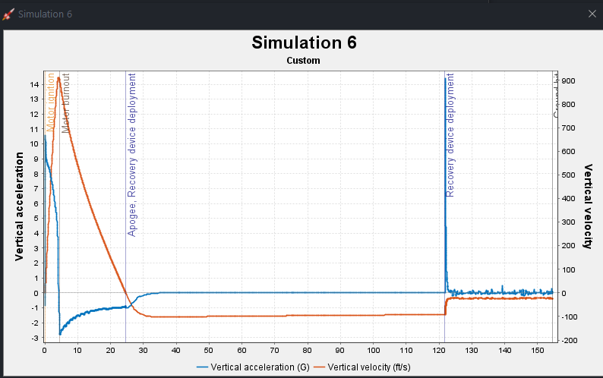

Figure 8 Velocity and acceleration vs time graph

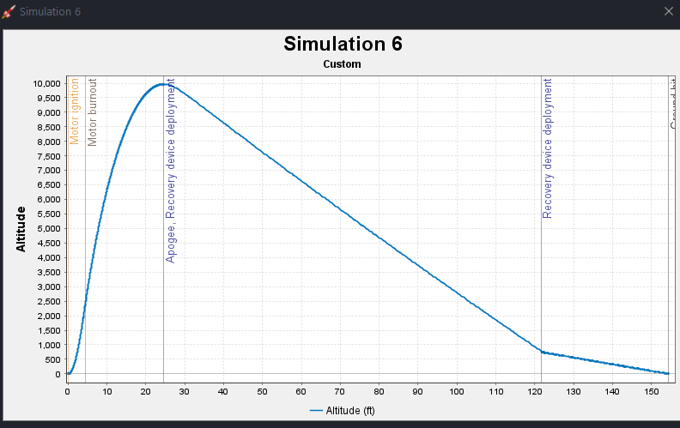

Figure Altitude vs Time graph

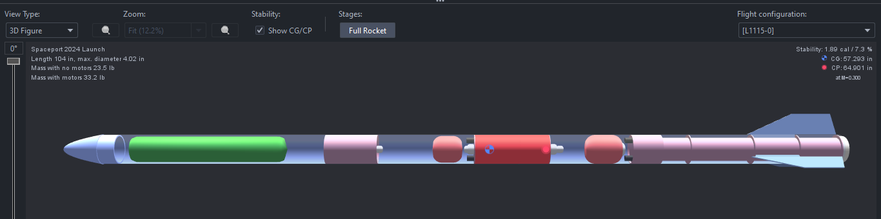

Figure 3D render of rocket from OpenRocket

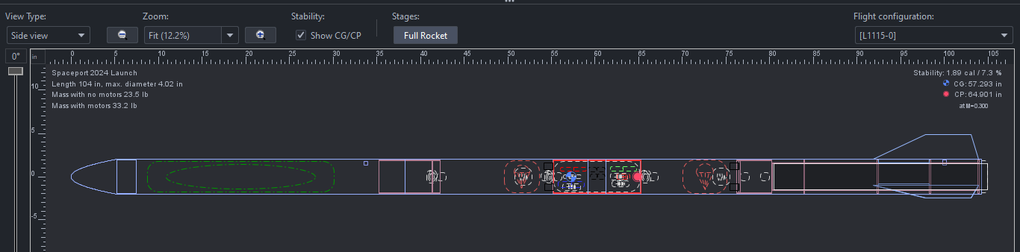

Figure Flat design of rocket from OpenRocket

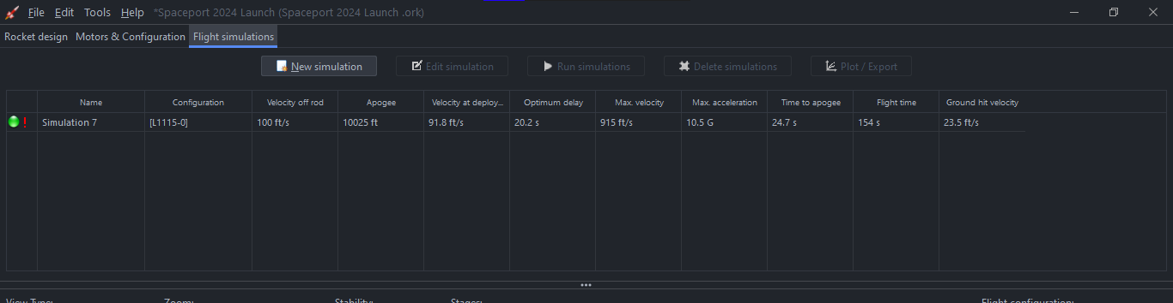

Figure 12 Simulation results from OpenRocket

**Appendix B: Project Test Reports**

1. **Test Launch 1**

Saturday February 24th, 2024

This launch was the team's first launch of the season, and it was nominal. The payload was replaced with a mass object as this flight was intended to test the launch vehicle itself and recovery systems. Standard dual deployment was used on this flight, as opposed to laundry line deployment. This was due to the team mentor/flyer of record reducing complexity with the addition of new team members. This launch was in Dalzell, South Carolina with Rocketry South Carolina. An Aerotech K-805 motor was used to achieve a 2652 ft AGL apogee.

|  |  |
| --- | --- |
| Test Flight 1, February 2024 (Taken from RRC3) | |
| Motor | Aerotech K-805 |
| Apogee | 2652 ft AGL |
| Max Velocity | 540 ft/s |
| Accent Time | 12.7 s |
| Decent Time | 49.9 s |
| Drogue Decent Rate | 84 ft/s |
| Main Decent Rate | 33 ft/s |

Table 5 Test Flight 1 Data

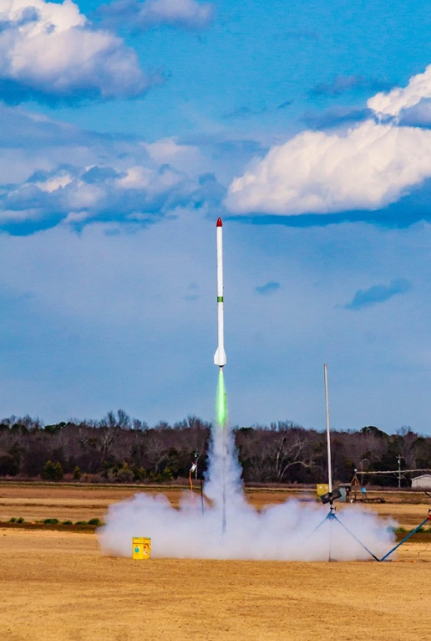

Figure Photo from first test launch (photo by Wes Munn)

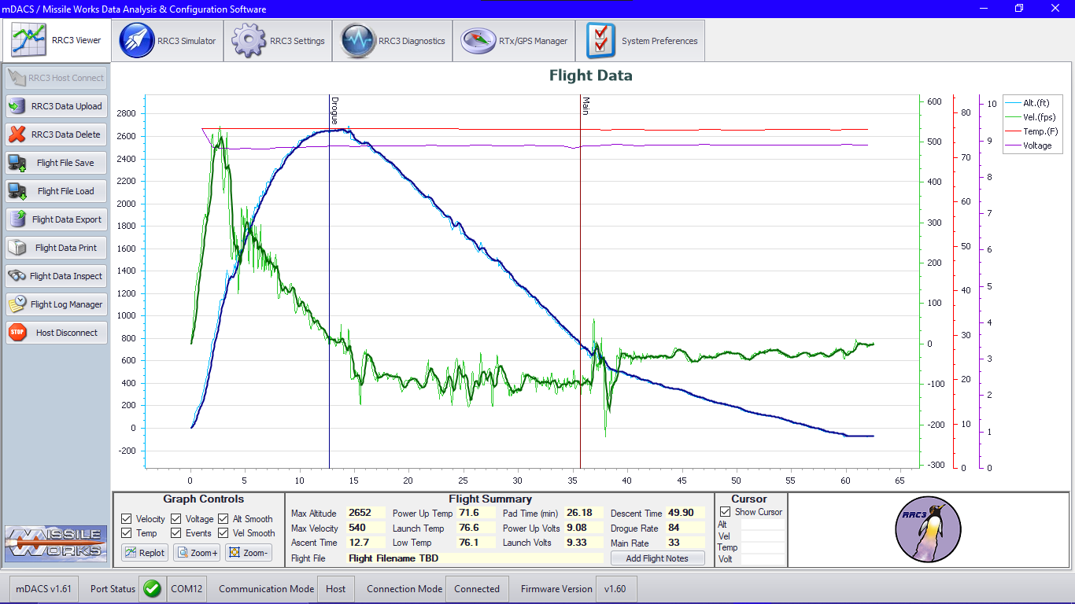

Figure 14 Test Launch Data from RRC3

1. **Test Launch 2**

Sunday May 5th, 2024

This was the team’s second launch of the season, and it was nominal. The team used laundry line style recovery to simulate and test the method we will use at 2024 SAC. The payload was very similar to what will be flown at the SAC. The egg survived! This launch was in Dalzell, South Carolina with Rocketry South Carolina.

|  |  |
| --- | --- |
| Test Flight 2, May 2024 (Taken from RRC3) | |
| Motor | Aerotech K 1100 |
| Apogee | 2201 ft AGL |
| Max Velocity | 412 ft/s |
| Accent Time | 11.65 s |
| Decent Time | 49.7 s |
| Drogue Decent Rate | 69 ft/s |
| Main Decent Rate | 31 ft/s |

Table Test Flight 2 Data

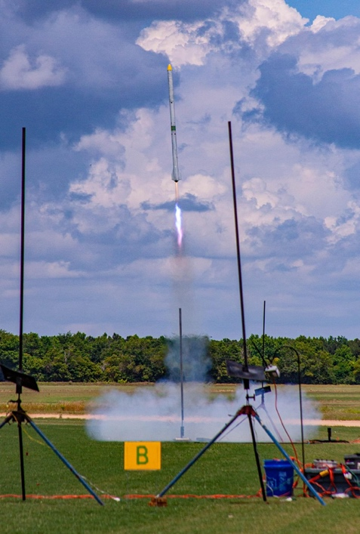

Figure Test Flight two takeoff (photo by Wes Munn)

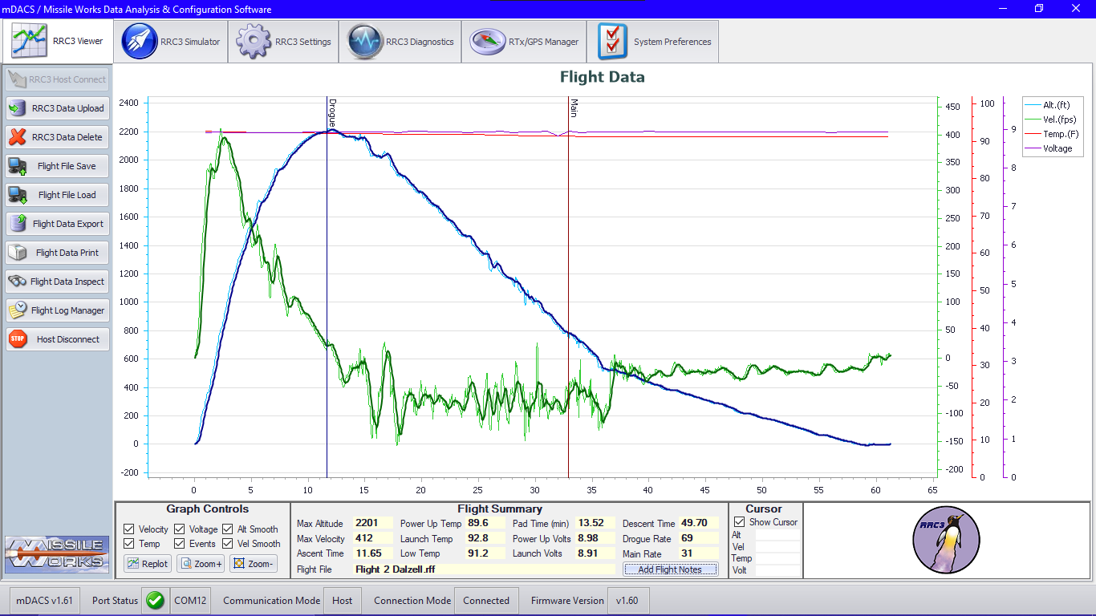

Figure 16 Test Flight two flight profile graph RRC3

## **Charge Testing**

Our initial ground testing for the previous rocket design is as follows; ground testing was completed using 2.0g for the drogue and the main parachute. The charge of 2.0g was determined to be adequate, severing the shear pins and separating the two body sections and significantly. These values led to a nominal recovery of the rocket during the team’s February and May launches. It is the informed opinion of this team that, due to both ground testing and test flights, the 2.0g primary and 2.5g backup charges will be sufficient for nominal parachute deployment.

**Appendix C: Hazard Analysis**

|  |  |  |  |  |  |
| --- | --- | --- | --- | --- | --- |
| Hazard/Hazard Level | Very Low | Low | Medium | High | Very High |
| Minor injury to  spectators by  rocket parts |  |  |  |  |  |
| Major injury to  spectators by falling rocket parts |  |  |  |  |  |
| Moving around  on the VLA/Work  station |  |  |  |  |  |
| Dehydration on the  VLA |  |  |  |  |  |
| Snakebite on the  VLA |  |  |  |  |  |
| Thorn in shoe or  hand on the VLA |  |  |  |  |  |
| Heat Exhaustion |  |  |  |  |  |
| Allergic reactions |  |  |  |  |  |
| Altitude Sickness |  |  |  |  |  |
| Muscle strains |  |  |  |  |  |
| Chemical Exposure |  |  |  |  |  |
| Noise induced  hearing loss |  |  |  |  |  |
| Dust inhalation |  |  |  |  |  |
| Electric Shock |  |  |  |  |  |
| Foodborne Illness |  |  |  |  |  |
| Communicable diseases |  |  |  |  |  |
| Overexertion |  |  |  |  |  |
| Extreme weather events |  |  |  |  |  |
| High winds |  |  |  |  |  |
| General wildlife encounters |  |  |  |  |  |
| Fatigue related injuries |  |  |  |  |  |
| Stress |  |  |  |  |  |
| Rocket set up and motor installation |  |  |  |  |  |
| Charge wells ignite on the launch pad |  |  |  |  |  |
| Launch rail falls on someone or someone’s head |  |  |  |  |  |
| Ground fire near rocket after launch |  |  |  |  |  |
| Rocket does not lift off launch pad |  |  |  |  |  |
| Failure of motor casing |  |  |  |  |  |
| Noise from motor startling livestock or pets |  |  |  |  |  |
| Unstable flight causes a collision of the rocket with people or property |  |  |  |  |  |
| Rocket breaking up during flight which causes falling debris from over one hundred feet |  |  |  |  |  |
| Failure of centering rings |  |  |  |  |  |
| Collision with aircraft |  |  |  |  |  |
| Ballistic descent of rocket |  |  |  |  |  |
| Uncontrolled descent due to a tangle, strip or failure in the shock cords, parachutes, or parachute protectors |  |  |  |  |  |
| Excessive parachute drift causing the rocket to land in White Sands Missile Range |  |  |  |  |  |
| Rocket is hung up in elevated location, i.e., powerlines or trees |  |  |  |  |  |
| Rocket descends onto a road |  |  |  |  |  |
| Quicklinks are not attached when rocket is being assembled causing the rocket to come down not under chute separated |  |  |  |  |  |
| Motor flies through rocket or motor falls out and is a spinning motor outside of the rocket. |  |  |  |  |  |
| Altimeters are not programmed correctly, causing a ballistic flight or a high velocity deployment |  |  |  |  |  |
| Fins fall off during launch causing a very unstable flight posing a risk to spectators |  |  |  |  |  |
| Motor blowby |  |  |  |  |  |
| Nosecone breaks during launch |  |  |  |  |  |
| Bulkheads shear in the altimeter bay or payload section causing an unstable flight |  |  |  |  |  |
| Rail button breaks off when loading on the rocket |  |  |  |  |  |
| Drag separation of rocket resulting in non-nominal boost |  |  |  |  |  |
| One or more BP charge not blowing resulting in a live charge that blows upon picking up the rocket after landing injuring someone severely |  |  |  |  |  |
| While driving out to retrieve the rocket a flat tire or crash occurs |  |  |  |  |  |
| A thunderstorm or severe weather event such as lighting strike hurts someone |  |  |  |  |  |

**Fig: XIII:** Hazard assessment table

**Appendix D: Risk Assessment**

|  |  |  |  |  |
| --- | --- | --- | --- | --- |
| **Team** | **Rocket/Project Name** | **Date** |  |  |
| 54 | Breaking BEAR-iers again | 5/7/2024 |  |  |
| **Hazard** | **Possible Causes** | **Risk of Mishap and Rationale** | **Mitigation Approach** | **Risk of Injury after mitigation** |
| Minor injury to  spectators by  rocket parts | Accident resulting in a minor injury to the spectators  being hurt by the rocket or parts | Medium, student-built rockets can be unreliable and unpredictable | Solid construction of rocket safety inspections by ESRA officials | Low |
| Major injury to  spectators by falling rocket parts | Accident resulting in a major injury to the spectators  being hurt by the rocket or parts | Medium, student-built rockets can be unreliable and unpredictable | Solid construction of rocket safety inspections by ESRA officials | Low |
| Moving around  on the VLA/Workstation | Slip, trip, or fall, sunburn, insect bite | High, as there will be a lot of equipment around to trip or fall over, sunburn is high in New Mexico at this time of year, also insects will be present | A clean workplace is a safe workplace wear sunscreen and bug spray | Medium |
| Dehydration on the VLA | Lack of adequate hydration | Very high, people forget to drink their needed water for the day | Drink water days  before the team will be out on the VLA, make sure the team always has water | Medium |
| Snakebite on the VLA | Team member does not see the snake or steps on the snake | Very high (depending on the snake) if venomous extremely high. Determine if  the snake was venomous or not and call ESRA officials on the radio GPS backpack | Tell team members to watch where they are stepping, be cautious when on the VLA searching for the rocket | Medium |
| Thorn in shoe or hand on the VLA | Team member does not watch their step, or falls and places their hand on to a spiky plant | High (as there is a lot of spiky plants on the VLA) | Tell team members to watch where they are stepping, watch out for holes | Medium |
| Heat Exhaustion | Team member gets overheated, becomes lethargic or passes out | High (high temperatures and out in the elements for prolonged period) | Pay close attention to teammates, brief them on proper hydration methods and tell them to recognize signs of heat exhaustion | Medium |
| Allergic reactions | Different climate than North Carolina with different allergens | Medium, team member could feel sick and could not be able to participate | Brief team members on changing climate, advise them to be cognizant of symptoms so the team can provide anti-allergy medicine | Low |
| Altitude Sickness | Height above sea level for Spaceport could hinder a teammates ability to perform at their best at Spaceport | Medium, as team member get altitude sickness | Brief team members on the changing high altitude, make sure they are aware, and could prepare by exercising more the week before Spaceport | Low |
| Muscle strains | A muscle strain could occur while carrying rocket parts to the VLA and to the judge's table | Medium, as it is possible the team could be holding the rocket for a long time | Make sure to alternate team members that are holding the rocket, and to make a holder for the rocket | Low |
| Chemical Exposure | Due to other teams and our team prepping our rocket with energetics, if we are exposed to those chemicals, it could be harmful to our health | Medium, as most chemicals are contained/sealed | Make sure to properly seal all chemical containers, do not approach other teams who are dealing with chemicals | Low |
| Noise induced  hearing loss | Due to loud rocket launches, the ears could become overwhelmed | Low, as we will be far away from rocket launches | Make sure to stay in designated areas | Low |
| Dust inhalation | Due to the amount of dust present in New Mexico as well as dust storms, dust inhalation could exacerbate existing respiratory conditions or trigger asthma attacks | Medium, as dust storms are frequent, and the wind could be high on launch day | Make sure to bring a mask, if possible, to prevent dust inhalation, and move into a vehicle if needed | Low |
| Electric Shock | Due to the electronics in our rocket and electronics in the area, there is a potential to get shocked by electricity | Medium, as if the team is following checklists for assembly if needed or observant of area, the risk should be minimal | Follow checklists and be observant of surroundings | Low |
| Foodborne Illness | Due to the high temperatures of Spaceport, if someone brings perishable food, then eats it, they are susceptible to food poisoning | Low, as team members will unlikely bring perishable items out to the VLA, and the team will encourage team members to not bring perishable items | Do not bring perishable items to the VLA and advise team members not to | Low |
| Communicable diseases | Due to the proximity of people, transmittance of a diseases is possible | Medium, as people from around the world will be in proximity with each other | Be aware of symptoms, tell team members if you are feeling sick, a trip to the hospital could be needed if symptoms bad enough | Low |
| Overexertion | Due to the intensity of the VLA, one could overexert themselves for the team | High, as there is high heat, high stress, and high stakes | Make sure to check on teammates, ask them how they are feeling, and to tell them to sit down or take a break if they seem to not feel great | Medium |
| Extreme weather events | Due to the unpredictability of weather, it is possible an extreme weather event could happen | Medium, as we should not be in the rainy season of New Mexico | Check weather for the day, do not launch during severe weather, do not drive to VLA in severe weather | Low |
| High winds | Due to high winds being very possible during the event, caution is needed if they occur | High, as winds could blow over people and tents | Check wind forecast, secure down materials, get in a vehicle if the wind gets very bad | Medium |
| General wildlife encounters | Due to the remote location, encounter with coyotes. Scorpions and snakes are possible | Medium, as although possible, these animals will try to stay away from humans unless provoked | Make sure team members are watching where they are stepping and being observant of surroundings, and to let ESRA officials know of wildlife sightings, and if bit or stung, to also radio into ESRA or to let an ESRA official know directly | Low |
| Fatigue related injuries | Due to the stress and demands of the competition, some team members may be sleep deprived | Medium, as team members will likely be physically and mentally tired | Make sure team members get on average 7 to 8 hours of sleep per night, and to eat a balanced diet | Low |
| Stress | Due to the immense stress on the competition, team members may feel lethargic and have low mental energy | Medium, as team members will likely be stressed | Make sure the team is checked up on from a stress perspective, make sure people have their concerns heard | Low |
| Rocket set up and motor installation | There is a premature ignition of the motor while mentor is installing it | Low, as mentor/flyer of record has installed many igniters without a failure | Make sure mentor/flyer of record knows correct safety measures and that there is not a live wire running to the igniter | Low |
| Charge wells ignite on the launch pad | There is a chance an altimeter or wire could short and the charge wells in the main and drogue section ignite | Medium, as although possible, the risk is small due to our team never experiencing a situation like this, and we throughougly check our avionics bay for shorts | Check avionics bay for short | Low |
| Launch rail falls on someone or someone's head | Due to loading the rocket, if the launch rail falls on someone, it could cause serious injury | Low, as multiple people are always holding the rocket as it is being lifted off the launch pad | Make sure multiple people are raising the rocket on the launch pa | Low |
| Ground fire near rocket after launch | Due to the rocket launching the flames could catch the ground on fire | Medium, as there is always a chance with a dry desert for shrub to catch fire from a rocket exhaust | Make sure that there are fire personnel on site to take care of the fire |  |
| Rocket does not lift off launch pad | Could cause the ground fire as explained above | Low, it is unlikely to the rocket to get stuck on the launch pad due to the forces involved in a launch | Make sure the launch rail is greased, and rail buttons can slide on a 15-15 rail |  |
| Failure of motor casing | Could cause the motor to fly through the rocket | Low, as our mentor and flyer of record has bult tens of rocket motors of the same classification(L) and is L2 certified | Have another team member who is knowledgeable about motor construction watch our flyer of record build the motor and check each step he does with the instruction booklet | Very low |
| Noise from motor startling livestock or pets | Horses, cows, or other pets on the VLA could be scared by the rocket taking off | Low, as there will be many rockets launches that day, and they will likely find a safe area away from the noise | No mitigation possible, the rockets will be loud, but ensure no horses are near the range if they are | Very low |
| Unstable flight causes a collision of the rocket with people or property | If the rocket comes off at a severe angle from the launch pad, it could veer towards the prep/spectator area and possibly hit a car or person, causing significant bodily harm | Low, as ESRA as many safety measures in place, as well as the launch pad being very secure, as well as the rail | Ensure launch pad is fixed, and everything is secure on the pad (ESRA officials will check the pad before launch) | Very low |
| Rocket breaking up during flight which causes falling debris from over one hundred feet | If the rocket breaks up and debris is falling, then there is a possibility of the rocket falling at high speeds to hit a person or property, damaging property, and severely injuring a person | Low, as for this to happen, the motor needs to go through the rocket, which is unlikely based on our two successful test launches | Double check fin can for any construction issues or damage, have a team member who has knowledge in motor assemblage, watch the flyer of record build the motor | Very low |
| Failure of centering rings | If centering rings fail, just like a failure of the motor casing, the rocket could fly through the rocket, or the rocket could rapidly disassemble | Low, as due to our two test flights, the centering rings have withstood launch forces | Double check the fin can for any damage before your test flight | Very low |
| Collision with aircraft | If an aircraft flies into the VLA, and the rocket flies at the same time, there could be a collision with the aircraft and rocket | Low, as the airspace above the VLA is controlled | Always have the RSO check and give the call that the range is clear | Very low |
| Ballistic descent of rocket | Ejection charges do not occur, and rocket does not separate | Medium as the charges could become damp, or an e-match is not checked for continuity | Always prep the charges in a dry environment, double check the e matches for continuity before packing the charges | Low |
| Uncontrolled descent due to a tangle, strip or failure in the shock cords, parachutes, or parachute protectors | Due to possible tangling during parachute packing, high winds at high altitudes causing a shear force on the shock cords causing them or the parachutes to fail | Medium, as there is always a chance a parachute, shock cord, or parachute protector could be packed incorrectly, and we cannot control high altitude winds | Pack parachutes the night before the launch and be methodical on packing them following the checklist for details on folding and how to pack | Low |
| Excessive parachute drift causing the rocket to land in White Sands Missile Range | Due to high winds or a main deployment at apogee, the rocket could drift over the mountains at the VLA and into white sands missile range | Medium, as if there is black powder charge leakage into the avionics bay, it could simulate a change in air pressure and deploy a main at apogee | Make sure to put poster putty over wires holes in avionics bay, and make sure altimeters are programmed to the right settings so a main will not deploy at apogee. This is in conjunction with following checklists | Low |
| Rocket is hung up in elevated location, i.e., powerlines or trees | Due to the unpredictability of a rocket launch, there is a possibility that during descent the rocket lands in either the mountains surrounding spaceport or on a powerline | Medium, as even though it has a low chance of occurring, there is still a chance, and the added danger of it being in a powerline and a shock occurring if someone tries to get it out | Cannot prevent powerline landing but can prevent a mountain landing by following checklist to prevent a main deployment at apogee. If landed in powerline no team members will attempt to get it out | Low |
| Rocket descends onto a road | Due to the unpredictability of a rocket launch, there is a chance that the rocket could land in a road, this could cause either a direct collision with a vehicle or a vehicle could hit the rocket causing injury to the car | Medium, as there is always a chance it could occur | Angle rocket away from roads if needed based on wind of the day | Low |
| Quick links are not attached when rocket is being assembled causing the rocket to come down not under chute separated | A team member forgot to attach the quick links when assembling the rocket, meaning the team member did not follow the checklist | Medium, as it is one step that is easy to forget to do without a checklist on hand or if the person who is supposed to keep the checklist is not paying attention | Make sure the checklist person has the checklist book on hand and is reviewing each step carefully | Low |
| Motor flies through rocket or motor falls out and is a spinning motor outside of the rocket | Motor retention ring falls off or is lost at the VLA | Low, as this has not occurred during our previous two launches and the team always tightens down the slimline retainer. Additionally, we have a backup retainer in case we lose a retainer on the launch site | Make sure both motor retention rings are on the packing checklist, and the motor retainer ring is installed during the build checklist | Very low |
| Altimeters are not programmed correctly, causing a ballistic flight or a high velocity deployment | Incorrect programming due to team member error or programming fault | Medium, as there is a chance we forget to change our flight parameters and a high velocity deployment happened | Double check on the build checklist that the altimeters are programmed to the correct values | Low |
| Fins fall off during launch causing a very unstable flight posing a risk to spectators | Damage to fins during travel to Spaceport | Medium, as there is always a chance to damage the fins during transport | Double check fins for structural integrity before launch | Low |
| Motor blowby | Motor was made incorrectly | Medium, as there is always a chance that the motor or grains are not optimal, even if the motor is built 100% correctly | Double check the flyer of record building the motor for the structural integrity of the parts and the condition of the motor grains | Low |
| Nosecone breaks during launch | During the force of launch, and the high velocity of flight, the nosecone breaks | Low, as we have flown 3D printed PETG nosecones reinforced with a fiberglass bulkhead for in total five launches, all without any problem | Reinforcing nosecone before Spaceport | Very low |
| Bulkheads shear in the altimeter bay or payload section causing an unstable flight | Due to the G-forces during launch, bulkheads could break causing a shift in mass | Medium, as there is always a chance of a part shearing during launch to the G-forces involved | Making sure to secure all launch critical bulkheads | Low |
| Rail button breaks off when loading on the rocket | Due to stresses on the rail buttons when loading the rocket on a rail button can fall | Medium, because of the stresses and weight of the rocket on the rail buttons and their small size | Careful loading of the rocket based on the at the pad checklist | Low |
| Drag separation of rocket resulting in non-nominal boost | Due to shear pins breaking off early | Low as we have three shear pins for the drogue section, and four for the payload section along with no shear pins breaking off during launch in each of the two tests launches | Taping over shear pins before launch at the VLA | Low |
| One Charge not blowing resulting in a live charge that blows upon picking up the rocket after landing injuring someone severely | Due to electrical fault | Low, as this has not occurred during our previous two launches | Follow all checklists, use anti-static pad while prepping electronics | Low |
| While driving out to retrieve the rocket a flat tire or crash occurs | Due to potholes, poor road conditions, and other drivers | Medium, as road conditions will not be known until launch day, and we cannot control other people's actions | Follow all applicable road safety laws | Low |
| A thunderstorm or severe weather event such as lighting strike hurts someone | Due to open area and location | Low, as it is unlikely someone will be struck by lightning | Follow all safety precautions and do not go outside at the VLA when there is a thunderstorm | Very low |

**Fig XIV:** **Risk Assessment table**

**Appendix E: Assembly, Preflight, Launch, and Recovery Checklists**

*A. Packing Checklist*

Rocket Checklist

1. Fin Can
2. Motor
   1. CTI 4 grain 75mm motor Casing
   2. Lithium grease
   3. Forward closure
   4. Aft closure
   5. I-bolt for forward closure
   6. CTI L1115 Propellent and liner
   7. Igniter and rod to push igniter
   8. Negative retention closing
3. Recovery
   1. Charge plate
      1. Black Powder for charge plate
      2. E-Match for Charge Plate
      3. Female JST wires for charge plate
   2. 60 Inch Rocketman Main Parachute
   3. 24 Inch Rocketman high performance drogue parachute
   4. 4 Large quick links
   5. Medium sized quick link
   6. 1x12-foot and 2x25-foot Nylon shock cords
   7. Three 2-56 shear pins
4. Payload Tube
   1. Payload (See payload Checklist)
   2. Four screws in rivets
   3. Three 2-56 shear pins
5. Altimeter bay
   1. Electronics
      1. RRC3
         1. Programing cable
      2. PF
         1. Programing cable
      3. FW
         1. Ground Station
      4. BRB
         1. Programing cables
         2. Radio
         3. Antenna and cords
      5. Two 4 pack 1.4V NIMH batteries
      6. Two 9V Batteries
   2. Hardware
      1. Two 14 in ¼-20 Rods
      2. Eight ¼-20 bolts
      3. Two-piece altimeter sled
      4. O ring
      5. Bottom fiberglass bulkhead
      6. Four rotary switches

Payload Checklist

1. Parts
   1. Nose cone
   2. Internal fiberglass tube
   3. Fiberglass bulkheads x8
   4. Flushed coupler
   5. Inset coupler
   6. Egg
   7. Egg restraint system
   8. RunCam 6 x2
   9. Thermoelectric coolers x2
   10. Heat sink x2
   11. Fans x2
   12. Temperature sensors x4
   13. Arduino
   14. Switches x4
   15. 16 AAA batteries and 4 packs
   16. 4 AA batteries and pack
   17. 6V lantern batteries x2
   18. ¼-20 Threaded rods x4
   19. ¼-20 Nuts x72
   20. Shock cord
   21. Quick link
   22. Rivets

General Tools/Parts

1. Tools
   1. Wire Strippers
   2. Hammer
   3. Wire cutters
   4. 7/16” Open ended wrench
   5. 7/16” Socket
   6. #2 Phillips Screwdriver
   7. Flathead Screwdriver
   8. Knife
   9. Side Cutters
   10. Soldering Iron
   11. Wall Mounting Puddy
   12. Heat Gun
   13. Drill
       1. Drill set
       2. Bit set
   14. Allen key set
   15. Small screwdriver set
2. Parts
   1. Heat shrinks
   2. Solder
   3. Solder Station
   4. Cups for black powder
   5. Weigh paper for black powder
   6. Tubes for black powder
   7. Scale
   8. Black Powder
   9. Tenergy NIMH AA battery charger
   10. Spare 9V batteries
   11. Electrical Tape
   12. Masking tape
   13. Zip ties
   14. 5 min epoxy
   15. Loctite
   16. Mounting Puddy

*B. Assembly Checklist*

1. Rocket

1.1 Altimeter Sled

1.1.1 Disassemble the aft end of the altimeter bay by unscrewing the quarter-twenty bolts.

1.1.2. Place removed quarter-twenty bolts into a box specified for parts relating to the altimeter bay.

1.1.3. Take off the aft bulkhead from the aft end of the altimeter bay.

1.1.4. Screw down all wires for each deployment event.

1.1.4.1. Screw down Main into the main connection for PF

1.1.4.2. Screw down Drogue Primary into the drogue connection for the PF, at apogee plus one. 1.1.4.4. For the RRC3 altimeter, the payload Secondary goes into the drogue connection.

1.1.4.5. For the PF altimeter, the main chute primary goes into the main connection.

1.1.5. Check all batteries for the altimeter and trackers to see if they have charge, if they do not have adequate charge, acquire a charged battery

1.1.6. Connect all altimeters to their respective batteries in series starting with PF, then RRC3 and then the FW and BRB to test pinging and satellites as well as testing continuity of drogue and main connections on all altimeters.

1.1.7. Turn each of these altimeters on using the rotary switches for each respective altimeter.

1.1.9. Continuity for drogue and main for the RRC3 altimeter is three quick beeps.

1.2.0. If three quick beeps are not heard, check screw connection points and troubleshoot until continuity is achieved.

1.2.1. Connect the battery to the Featherweight Tracker.

1.2.2. For the Featherweight, connect to the Featherweight on the iFIP app on your smartphone.

1.2.3. Turn on the Featherweight ground station and connect the ground station to the iFIP app on your smartphone.

1.2.4. Once connected to both, both Featherweight and ground station both should have a light blue highlight. This means they are both connected and communicating through your smartphone.

1.2.5. Check for GPS lock on the Featherweight through the app, and check if signal strength is good or bad.

1.2.6. To determine if signal strength is good or bad, follow the following color guidelines on signal strength.

1.2.6.1. Orange, signal strength of less than 24 dB-Hz. Meaning this signal is weak and can result in 10s of horizontal error.

1.2.6.2. Yellow, signal strength of 24 to 32 dB-Hz. Meaning this signal is O.K. and could add a small amount of inaccuracy.

1.2.6.3. Green, signal strength of 32 to 40 dB-Hz. Meaning this signal is good, and full accuracy is available.

1.2.6.4. Blue, signal strength of 40 and Over dB-Hz. Meaning this signal is very good and has full accuracy with margin.

1.2.7. Connect the battery for the Beeline tracker to the Beeline Tracker.

1.2.8. Turn on the radio receiver and listen for a good clear tone of communication between the Beeline tracker and the receiver.

1.2.9. Check the screen to see if there is a good connection between the tracker and receiver, a connection is displayed on the receiver screen on a scale between 1 and 9. With a good signal strength being 9 and a bad signal strength being 1.

1.3.0. Turn the key switch for the trackers and altimeters to the off position.

1.3.1. Acquire the forward-facing bulkhead black powder charge vials.

1.3.2. Load the electronics sled into the altimeter bay. When doing so, make sure no wires get pulled or twisted as the electronics sled is going in.

1.3.3. Place the aft facing bulkhead onto the altimeter bay and use the quarter-twenty nuts to screw the aft facing bulkhead in place.

1.3.4. If there is a possibility of the wires being twisted or pulled, take the altimeter sled back out and re-test continuity of the sled.

1.3.5. Use a small piece of paper rolled up to create a funnel to pour the black powder charges into the charge wells.

1.3.6. Once poured in, take a napkin or tissue paper, and tear the paper into one to two-inch sections.

1.3.7. Put these pieces of paper and pack them into the charge wells until there is substantial resistance and the pieces of paper start to get hard to push in.

1.3.8. Use one inch width electrical tape and tape over the hole used for the electrical match so no black powder will escape out of this hole.

1.3.9. Tape over the charge well in a plus sign pattern first, then tape around the bottom of the tape pieces at the bottom of the charge wells used for the plus sign pattern.

1.4.0. Tape around the charge well until there is no visible charge well material or tissue material and should look like a cap on the charge well.

1.4.1. Test if the tissue packing is nominal by pressing down on the charge well, and if the tissue gives with slight pressure, repack the charge well.

1.4.2. Re-do the same steps above for the other forward facing bulkhead charge wells.

1.4.3 Put the motor into the fin can.

1.4.4. Screw retention ring for motor on.

1.4.5. Take the charge plate and place it in the fin can of the rocket until it is flush with the top of the fin can.

1.4.6. Acquire the black powder charges for the charge plate

1.4.7. Repeat steps, 1.3.5. to 1.4.0. With the charge plate vials for the charge wells on the charge plate.

1.4.8. Push the charge plate into the fin can until it stops.

1.5.3. Do a pull test on the parachutes, and have the team mentor verify all parachutes and attachments

1.5.4. Attach the quicklink from the parachutes to the U-bolt of the aft facing bulkhead of the altimeter bay.

1.5.5. Attach the two JST connectors to the other JST connectors on the aft facing bulkhead of the altimeter bay.

1.5.6. Push the fin can and altimeter bay together, and line them up.

1.5.7. Put in the shear pins that attach the altimeter bay to the fin can and keep it together during flight.

1.6.0. Place the payload section of the rocket onto the top half of the altimeter bay.

1.6.1. Once placed, put screws in their designated spots on the payload tube.

1.6.2. Walk to the launch pad.

*C. Preflight Checklist*

1. Check in with RSO
2. Wait in line to approach designated Pad
3. Safely lower launch rail to horizontal position
4. Load launch vehicle on 1515 launch rail
   1. Assure 3 team members have hands supporting launch vehicle at all times
   2. Make sure rocket is straight, no twisting, while loading
5. While 3 team members maintain contact with launch vehicle, raise launch vehicle to vertical position
6. Lock launch rail into vertical position
7. Determine appropriate launch angle (minimum 3 degrees)
   1. Check with launch pad supervisor for additional instruction
8. Verify launch angle with iPhone level
9. Set cameras around launch site at FOR direction
10. Set up/acquire step ladder for team lead to approach launch vehicle
11. Turn on thermoelectric coolers and fans by flipping the switches
12. Start recording on RunCam 6s through the hole
13. Turn on FW by turning key switch with flathead screwdriver
    1. Verify satellite connection with ground station and student smartphone
14. Turn on BRB by turning key switch with flathead screwdriver
    1. Verify pings with Yagi radio and antenna
15. Turn on RRC3 by turning key switch with flathead screwdriver

1. Wait for 3 short beeps.

1. Turn on PF by turning key switch with flathead screwdriver
   1. Wait for 3 short beeps
2. Have team lead step down and remove step ladder from launch area
3. Take pictures of team and rocket ready to launch
4. Team members step back appropriate distance from launch vehicle
5. FOR insert igniter
6. FOR attach leads to ignitor
   1. Be sure to check for no spark prior to attachment
7. Remove all team members from launch pad
8. Return to launch area as directed by pad supervisor

*D. Launch Checklist*

1.1. Have the team member on Featherweight tracking monitor location and GPS lock on their smartphone.

1.2. Have the team member on the Big Red Bee tracker monitor radio frequency feedback.

1.3. Have the team members on video production recording the launch vehicle prior to and during lifting off.

1.4. Listen and wait for the countdown events.

1.5. Have all necessary team members monitoring their respective positions.

1.6. Watch the launch vehicle lift off.

1.7. Listen and look for deployment events at apogee, and at 800 feet.

1.8. Continue to monitor trackers to determine the launch vehicles behavior.

1.9. Monitor and have assigned team members take a picture and note where the rocket is landing.

2.0. Determine if trackers are still nominally functioning.

2.1. Locate general direction of the launch vehicle.

1. *Flight Abort Checklist*
2. Confirm all team members are safely away from launch vehicle
3. Confirm with ESRA launch pad official that it is safe to approach launch vehicle
4. FOR carefully approach launch vehicle
5. FOR remove ignitor from motor
6. Once deemed safe by FOR, have team members approach launch vehicle
7. Have team leader set up step ladder near launch vehicle
8. Have team leader step up with flathead screwdriver in hand
9. Team lead turn off all avionics in the following order
   1. Turn switch to off position for RRC3
      1. Confirm RRC3 is off by lack of beeping
   2. Turn switch to off position for PF
      1. Confirm PF is off by lack of beeping
   3. Turn switch to off position for BRB
      1. Confirm BRB is off by lack of transmission to Yagi radio and antenna
   4. Turn switch to off position for FW
      1. Confirm FW is off by lack of feedback from ground station and team member smartphone
10. Team lead step back/down off ladder safely
11. Have, at minimum, 3 team members maintain 2 hand contact with the launch vehicle while safely and slowly lowering the launch vehicle/rail to horizontal position
12. Once launch vehicle/rail is horizontal, have, at minimum, 3 team members carefully slide launch vehicle off launch rail
    1. Ensure members do not twist or turn launch vehicle while removing it from the launch rail
13. Carefully, team members load launch vehicle into awaiting transportation
14. Return all team members and launch vehicle to prep area
15. *Recovery Checklist*
16. Have team leader acquire a flathead screwdriver to turn off altimeters
17. Ensure all team members have enough water for at least4 hours
18. Ensure designated team member has first aid kit
19. Use featherweight ground station and cell phone application to determine GPS location of launch vehicle
20. Use Yagi radio receiver (tuned to hear frequency transmissions of 100 MW BRB) with Yagi antenna to determine radio location of launch vehicle
21. Approach recovery queue and await instruction
22. Using cardinal coordinates, relay team’s estimated direction into Spaceport via radio
23. Once cleared, begin searching for launch vehicle
24. **If walking will take longer than 15 minutes** radio estimated position, direction, and time of travel to launch vehicle
25. **If in driving distance,** radio into spaceport which direction you are driving
    1. Be aware of wildlife and stick to marked trail if possible
26. **Always report to Spaceport via radio every 15 minutes with position and direction**
27. Radio into Spaceport when launch vehicle is found
28. Have team member take photos of launch vehicle landing (do not touch)
29. Video beeping and altimeter data as backup and for media
30. Turn off altimeters with flathead screwdriver (team leader)
31. Verify all charges have blown by taking picture with team member smartphone and visually confirming
32. **If driving,** have team members load launch vehicle into truck
    1. **DO NOT** repack parachutes or shock cords
33. **If walking,** have team members pick up launch vehicle
34. Radio into Spaceport that the team is returning and the direction of travel
35. Return to launch vehicle prep area
36. Turn on all altimeters
37. Listen to launch data
38. Turn off all altimeters and trackers

*F. Off Nominal Procedures*

1. Altimeter wires come loose during assembly
   1. Reattach wires, recheck continuity and functionality prior to resuming process
2. BP charge blows during assembly or testing
   1. If occurs at prep area
      1. Ensure safety and wellbeing of team members
      2. Remove power from charge circuit
      3. Disassemble and attempt root cause analysis
      4. Develop solution for future mitigation prior to moving forward
   2. If occurs at launch pad
      1. Ensure safety and wellbeing of team members
      2. Turn off all active electronics in avionics bay
      3. Slowly lower launch rail to horizontal potion and remove launch vehicle from rail
      4. Return launch vehicle prep area
      5. Disassemble and attempt root cause analysis
      6. Develop solution for future mitigation prior to moving forward
3. FW is unable to acquire GPS lock
   1. If occurs at prep area
      1. Cycle FW on and off
      2. If necessary, take to clear sky area and cycle on and off
      3. If necessary, replace with backup FW system and rerun all system checks
   2. If occurs at launch pad
      1. Cycle FW on and off twice
      2. If necessary, slowly lower launch rail to horizontal potion and remove launch vehicle from rail
      3. Return launch vehicle prep area
      4. Take to clear sky area and cycle on and off
      5. If necessary, replace with backup FW system and run all system checks
4. BRB is not transmitting signal
   1. If occurs at prep area
      1. Check power input and electrical connections
      2. If necessary, replace with backup BRB
      3. If all else fails, remove and fly without it
   2. If occurs at launch pad
      1. Cycle BRB power on and off twice
      2. If necessary, continue with launch without BRB transmission
5. RRC3 does not report as expected during startup
   1. If occurs at prep area
      1. Check electrical connections
      2. Cycle RRC3 on and off
      3. Attach LCD display and check for functionality
      4. If necessary, continue with backup RRC3 and run all system checks
   2. If occurs at launch pad
      1. Cycle RRC3 on and off twice
      2. Slowly lower launch rail to horizontal potion and remove launch vehicle from rail
      3. Return launch vehicle prep area
      4. Disassemble and attempt root cause analysis
      5. Develop solution for future mitigation prior to moving forward
6. PF does not report as expected during startup
   1. If occurs at prep area
      1. Check electrical connections
      2. Cycle PF on and off
      3. Attach data transfer kit and check for functionality
      4. If necessary, continue with backup PF and run all system checks
   2. If occurs at launch pad
      1. Cycle PF on and off twice
      2. Slowly lower launch rail to horizontal potion and remove launch vehicle from rail
      3. Return launch vehicle prep area
      4. Disassemble and attempt root cause analysis
      5. Develop solution for future mitigation prior to moving forward
7. Launch vehicle assembly does not occur as expected
   1. Take launch vehicle apart and attempt root cause analysis
   2. Develop solutions based on analysis
8. Shear pins do not insert properly
   1. Check coupler and body tube hole alignment
   2. Check if shear pins are proper size
   3. Attempt mitigation and if not possible, drill new shear pin holes
9. Motor does not insert properly into launch vehicle
   1. Remove motor and attempt root cause analysis
   2. Mitigate based on findings
10. Payload does not insert into launch vehicle
    1. Remove payload and attempt root cause analysis
    2. Mitigate based on findings
11. Damage to rail guides during launch vehicle loading
    1. Observe rail guides, determine if still functional
    2. If not, carefully remove launch vehicle from rail
    3. Return launch vehicle to prep area
    4. Replace/repair rail guides as necessary
12. Team lead falls onto rocket while attempting to activate electronics
    1. Ensure safety and wellbeing of team lead
    2. Check launch vehicle or raid for potential damage
       1. If damage is found, remove launch vehicle from rail and return to prep area for repairs
       2. If no damage is found, reset step ladder safely and have team member attempt to continue arming process
13. Ignitor cannot be properly inserted into motor
    1. Have FOR observe ignitor and preform root cause analysis
    2. Reattempt insertion, watching/feeling for blockages withing motor core
    3. If not possible, turn off all electronics and lower launch vehicle to horizontal position
    4. Remove motor from rocket and have FOR use flashlight to look for obstructions
    5. If cannot be resolved on pad, take launch vehicle back to prep area
14. Motor fails to ignite
    1. Have FOR remove initial ignitor
    2. Check for burn
       1. If burned, replace with backup and reattempt launch
       2. If not burned, have ESRA launch pad official check launch system for correct operation
15. Motor CATO while on pad
    1. Carefully retrieve any parts on ground around launch vehicle
    2. Lower launch vehicle to horizontal position and remove from launch rail
    3. Return to prep area and cry
16. BP charge goes off during launch vehicle recovery
    1. Set all launch vehicle components on ground
    2. Await arrival of FOR
    3. Allow FOR to preform root cause analysis and instruct further action
17. Student injury occurs during recovery
    1. Report via radio to Spaceport
    2. If possible, treat injury with first aid kit
    3. If severe, await medical assistance
18. Student suffers from overheating during recovery
    1. Report concern to Spaceport via radio
    2. Do best to provide student with additional water and move to shaded/cooler area
    3. If severe, seek immediate medical assistance
19. Not all charges have blown up on discovery of launch vehicle
    1. Set all launch vehicle components carefully on the ground
    2. All team members step back from launch vehicle to a safe distance
    3. Call for and await arrival of FOR
    4. Allow FOR to determine the direction of further action

**Appendix F: Engineering Drawings**

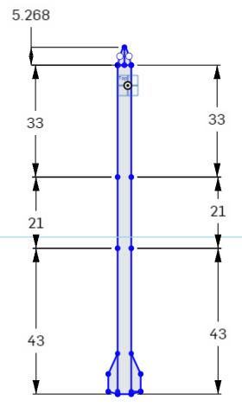

Figure CAD drawing of rocket components

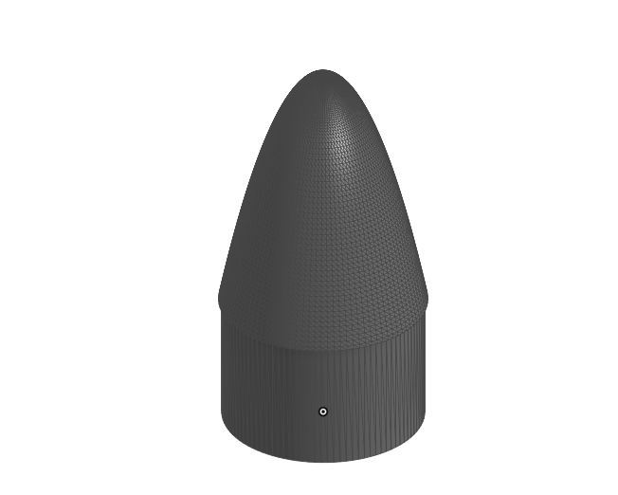

Figure Nosecone side profile 3D

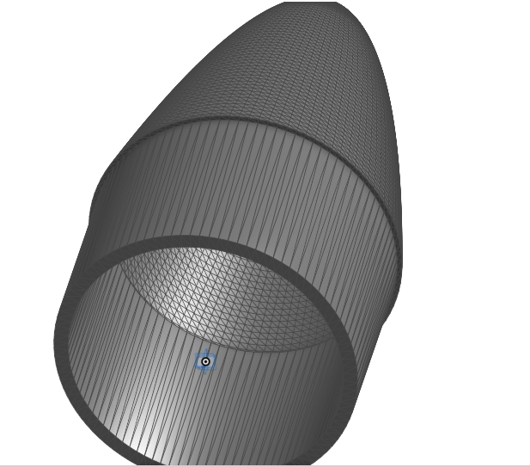

Figure Nosecone bottom profile 3D

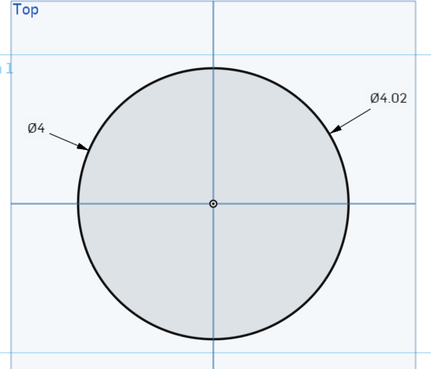

Figure CAD Nosecone Bottom View

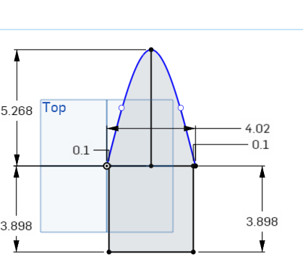

Figure CAD Nosecone Side View

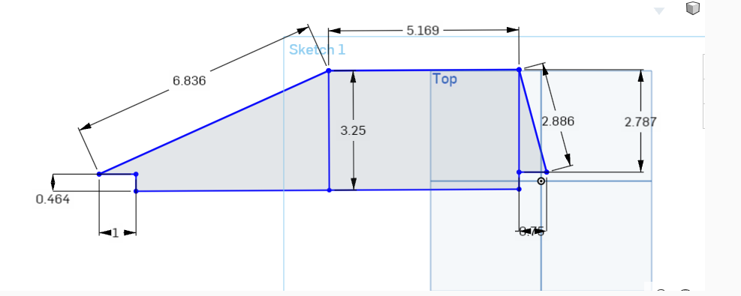

Figure CAD Drawing of Fin Design

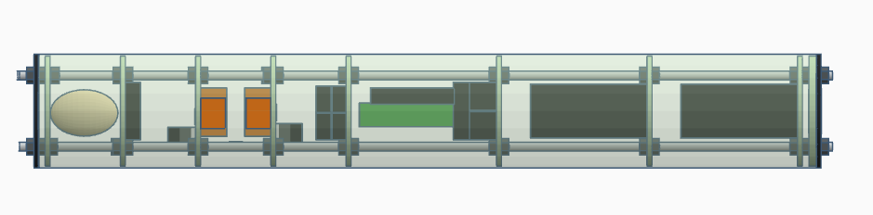

Figure 3D model of Payload Design

**APPENDIX E: Additional Photos of Project Construction**

# 

# **Acknowledgements**

The Lenoir-Rhyne University B.E.A.R. team would like to thank the following individuals and corporations, in no particular order, for their contributions of any kind that aided in the completion and entry of Breaking BEAR-riers: The Solar Polar Bear. Lenoir-Rhyne University School of Natural Science and Mathematics, Todd and Kelly Burwell, Wildman Rocketry, Mach1 Rocketry, Rocketman Rocketry, North Carolina Space Grant, and all of our other wonderful vendors and contributors. This project could not have been done without their support.